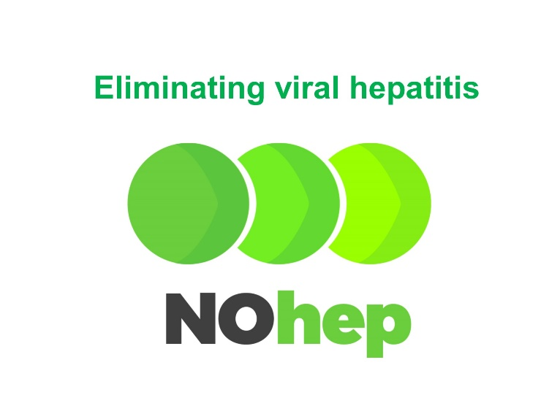

World Hepatitis Day

Today is World Hepatitis Day.

This year we celebrate World Hepatitis Day with the stories of people with haemophilia who have been cured of their hep C.
Watch our new video - HEP C - I AM CURED!
A NOHEP FUTURE
In 2017 we join the global community in support of the World Health Organisation’s commitment to eliminate viral hepatitis by 2030.

Imagine a future without hepatitis C.

Can we achieve this in the Australian bleeding disorders community?

I AM CURED OF HEP C

New revolutionary hepatitis C treatments are now available in Australia.

- High cure rates - 95% overall
- Few if any side effects.

We are pleased to hear from Haemophilia Treatment Centres that most people with bleeding disorders have now been treated and cured of their hep C.

What is it like to have the new treatment and be cured?
In our new video Paul and Len tell their personal stories.

WHAT CAN YOU DO TO HELP?

- Spread the word!
- Many people with bleeding disorders were exposed to hep C. Have you ever been tested? If you used factor before 1993 – even as a baby – you could be at risk. Act now – if you don’t know whether you have hep C or not, get tested!
- If you have hep C, talk to your doctor about treatment that could cure your hep C.

WHAT’S STOPPING YOU FROM TREATMENT?

Click here to find out more about solutions.

Read More about World Hepatitis Day and the new treatments…

